1. There are many ways to view the values of variables not the expressions which don’t exist in the program.
2. **Variable Section** under **Debugger Window**.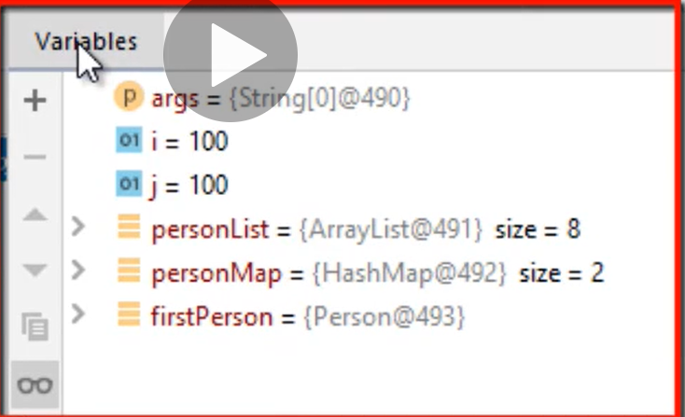
3. **Inline Way:**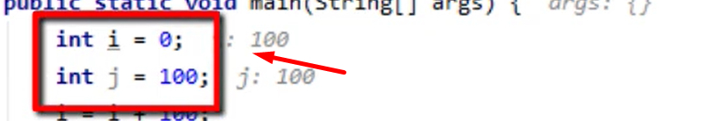
4. **By hovering** over variable and using the tooltip.
5. 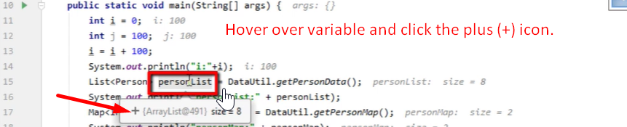
6. There are 3 ways to see variables’ values.
   1. Variables Panel.
   2. Inline way 🡺
   3. Tool tip 🡺 When hovering over variable.